**The “Text God” Formula: A Proposal to Continue Hacking Tinder Dating Strategy**



Emerson Fleming & Abhinav Kumar

Professor Rolfe

DACSS 602

December 19, 2021

**Introduction/Background**

Online dating first began in the 1980s with email communication and chat rooms[1]. By the mid-90s, the world of online dating began to privatize into an all new consumer space. In 1995, Match.com was launched in addition to niche dating sites such as JDate which catered to specific subsets of the population[2]. Overall, online dating has become an increasingly viable way to meet people of romantic interest. At this point, dating apps have exploded in popularity and now cater to everyone from farmers (FarmersOnly.com) to the rich and famous (Luxy.com). Studies suggest nearly 40% of the adult population have tried online dating in some capacity. Additionally, surveys show nearly 70% of the college-aged population are actively using online dating to find romantic partners[3].

While online-dating apps radiate potential in the world of dating, such apps exhibit their own shortcomings. One study conducted jointly by Boston University and MIT demonstrated 20% of participants admitted some degree of deceptiveness on their dating profiles[4]. Furthermore, 90% of online-daters believe their contemporaries lie on their dating profiles[5]. Other reports state nearly 40% of users stretch the truth on their online dating profiles[6]. The tendency for users to stretch the truth does not represent the only pitfall with online dating.

The vast majority of dating sites exhibit a skewed male to female ratio[7]. Tinder represents a dating platform with a somewhat balanced 55:45 male to female ratio[8]. Other dating sites exhibit as much as 80:20 male to female ratios.[9] Overall, men are twice as active as women on dating apps on average. The issue with this paradigm is that a shortage of females is created that skews the supply and demand against men. Furthermore, women view approximately 85% of men on online-dating apps as below the average level of attractiveness[10]. On average, an estimated 78% of all heterosexual female messages are sent to the top 15% of male users[11]. The problem is not that 85% of all males *are* unattractive, they are simply *perceived* as being unattractive. Therefore, to be successful in the world of online dating, outside help–preferably from a professional–is necessary for most heterosexual men. In order to test the efficacy of professional online-dating assistance, an experiment was conducted at UMass Amherst using 5 college-aged men. The following proposal outlines the results from this experiment and argues for a second follow-up experiment with a larger sample for more generalizable results.

**Problem statement**

Kelifer Pomeranz, a Bay Area psychologist, claims online dating becomes a part-time job for most. “Monitoring matches, swiping on profile after profile and sharing good banter with people of interest takes a lot of mental energy[12]”. Ghosting after texting exchanges is more than common and rejection is rampant in the male online dating community. Manu (name masked), a graduate student from India, met an American woman through the Bumble online dating app. For several days, Manu was sure he had found his next love interest. The conversation seemed exciting and the relationship exuded potential[13]. However, after several days of conversation, Manu was ghosted and unable to reach the woman for unclear reasons. Many conversational pitfalls exist in the world of online dating[14]. A solid profile for males only generates matches. In the world of heterosexual online dating, the majority of women expect men to initiate and carry the conversation and judge their ability to do so to determine whether they will meet in person[15]. This is intuitive and similar to dating in person. However, avoiding all online conversational pitfalls and actually generating a date with a woman is more difficult than it might seem for most men.

Overall, a considerable percentage of young men find the method of facilitating matches difficult as well through online dating applications. The same does not hold true as often with female users. Studies demonstrate even the best looking men fail to generate as many matches as even women of less social market value[16]. Overall, males are twice as active as females on dating apps and 5 times more likely to send the first message[17]. This creates an atmosphere in which women are bombarded with messages and are therefore far less likely to respond[18].

Overall, the purpose of the study is not to complain about the way things are. Instead, the aim is to make the realities of dating apps for hetersexual men more widespread and to propose ways to improve results. The reality is that an alarmingly small percentage of men enjoy the vast majority of results in the world of online dating[19]. The same does not hold true for women–as the following work will later prove. This results in widespread rejection for young men. Similarly to the real world of dating, only a small percentage of men naturally exhibit characteristics women consistently find attractive[20]. To make matters worse, these men cannot even explain to their friends or contemporaries how they express confidence and avoid the common pitfalls of the dating world. They represent the minority of men where “being themselves” actually works[21]. The reality is that if ‘being yourself” was good enough, then the vast majority of heterosexual men would not experience so much failure and frustration in the world of online dating. The solution is not to lie and mislead. The solution is to be the best online version of yourself. However, this concept likely requires outside professional help to fully implement.

An experiment will be proposed to further the findings of an approach that has proven to yield better results for each participant. The first experiment sought to find whether the ways of online dating professionals were tried and true methods to salvation or snake oil. Those that use online dating the most are college-aged individuals[22]. Therefore, college-aged men were selected as the group for the sample and will serve as the sample for the next experiment.

Five college-aged male students were selected for the first phase of the experiment to see if the methods of an online-dating app professional really worked. The most established and premier of Tinder dating app experts for heterosexual men is the Text God. The Text God offers a variety of services that range greatly in cost. In order to reduce expenditure and maximize efficiency, all Text God YouTube content was combined to form a blueprint of guidelines for profile creation. Biography forms an important part of packaging oneself for the online dating world as well. It reflects personality, humor and sometimes what the user is looking for in a relationship. Luckily, the Text God also includes methods for creating a great Tinder bio in addition to methods of taking the best pictures. These methods in conjunction form the basis of creating a solid profile.

These profile guidelines were utilized in addition to a paid MasterClass taught by Text God to teach participants better communication with potential females of interest. According to the Text God, a great profile only generates matches. In order to actually score a date, the male user must implement solid texting-etiquette. The first phase of the experiment was generated as follows. The principles of Text God were learned thoroughly by one dating coach that regurgitated the methods to each participant over the span of a week.

**Research Question:** How much better can you perform on dating

apps (Tinder) with a solid profile and better texting etiquette?

**Sample:** 5 college-aged young men.

**Treatment:** Each participant was to receive Text God profile guidelines gathered from all of Text God’s YouTube videos in addition to proper text etiquette guidelines taught in the Text God "Over The Top Text Game" MasterClass. Participant Tinder performance would be tracked

before and after they learned Text God methodology and profile coaching.

**Measurements:**

* Daily matches per 30 swipes
* Dates
* Ability to convert 5 matches to another platform
* Dates liked
* Super-Likes

TextGod Profile Guidelines[23]:

Pictures:

1. Take high quality pictures preferably on a high quality SLR camera. Most smartphones skew your likeness in a negative way.
2. Make sure the participant is smiling if they look into the camera.
3. Make sure the participant has a straight face if they look away.
4. Make sure pictures are taken above the waist.
5. Include a picture with your pet to demonstrate you are kind and trustworthy.
6. Do not use pictures with alcoholic beverages.
7. Do not include pictures with any form of smoking.
8. Take pictures during golden hour (if at all possible) or when the light is the very best in the day.
9. Take pictures outside if at all possible.
10. Use a maximum of 5 pictures.
11. Do not look like you are trying too hard in the pictures. This is a huge turn off for girls.
12. Absolutely no selfies.
13. Take pictures where their stance is wide and they look confident.
14. Ensure the participant wears stylish clothing they feel comfortable in.
15. Run the pictures through PhotoFeeler to see how they stack up.
    1. PhotoFeeler allows the user to pick whether they would like men or women to anonymously rate their pictures. The website gives users the ability to receive attractiveness, trustworthiness and intellect scores based on the pictures they submit. This is a great way to see how women feel about your pictures before you submit them to dating apps.

Bio[24]:

1. Ensure the bio is concise (no longer than 2 sentences).
2. Make it something funny that reveals humor and personality.
3. Keep it light-hearted, do not make it something serious.

Over The Top Text Game[25]:

*Overall, there are many bits and pieces across the Text God “Over the Top Text Game” masterclass in addition to his YouTube videos that help users avoid the pitfalls of ruining a Tinder conversation (or the chances of a match). This is why a coach will be designated with a considerable familiarity with Text God and all of his material.

*Note the following is only roughly what the Text God MasterClass includes.

How to approach each Tinder conversation:

1. Lead
   1. Say something that leaves her hanging and makes her wonder what you will say next. For example:
      1. “Let me get one cool but random fact about you. Mine would be that I once saw a celebrity get punched in the face”.
2. Understand
   1. Say something that emphasizes the common ground you guys both have or that you understand her. People like to be understood.
3. Tease
   1. Tease her but not in a mean or derogatory way at all. You don’t want to bully her as that is unethical and will make her want nothing to do with you. You just want to tease her in a light-hearted and funny way.
      1. For example: *She sends you a meme of a super unattractive guy wearing glasses. You then tell her something like “wow, I had no idea you wear glasses!” It is kind of funny but it’s so ridiculous that it isn’t necessarily insulting.
4. Sexualise
   1. This one you really have to be careful with. You want to sexualise in a very discreet way that is not vulgar or direct in any way whatsoever. Otherwise, it is a total turnoff.
      1. For example: *She’s wearing a bikini and you say something like: “I love how your bikini matches perfectly with the water.”
         1. Here, you are not necessarily being explicit in any way but you are letting her know you find her attractive without being creepy or complimenting her appearance specifically. If she is an attractive woman, the odds are she has been told so every day since she was born. Therefore, it will do you no favors to compliment her on her appearance (which she did nothing to earn other than be born).

*The following of these 4 components represent the 4 different approaches one can take when attempting to talk to a match on Tinder. The thing to remember is that you want to try one of these approaches out and see how she is responding. Ultimately, you want to see which approach works and continue using the same approach until you get her number and a date. If one approach is not working but she is still responding, just try another approach! The key is that you want to learn how she likes being approached and each woman is different

**Results**

*Figure I: Weekly Matches Before and After*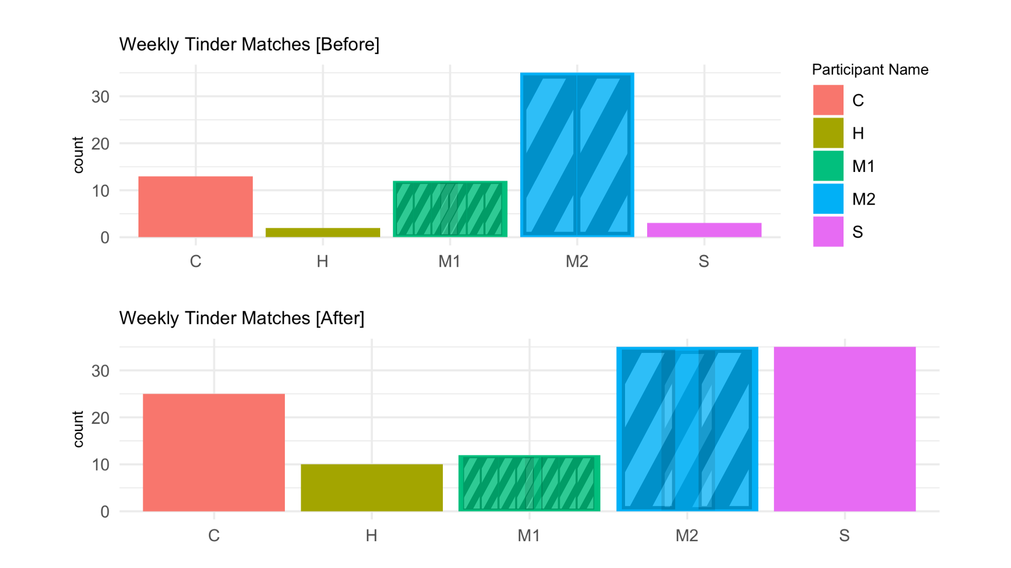

In Figure I, the comparison for weekly Tinder matches has been shown for before and after professional profile creation assistance. Participant names were masked for confidentiality purposes. It is important to note participants M1 and M2 did not receive new profiles. Participant M2 had a great profile that garnered over 3,000 matches over several years. Therefore, new profile pictures were not necessary for this participant. Participant M1 was the most resistant to Tinder profile help. When the experiment began, participant M1 was gracious but became increasingly resentful to outside assistance with his dating life as things progressed. This suggests assistance in dating life may be a sensitive topic for men. All participants that received professional guidance for profile creation improved in weekly matches. Participant C increased matches by 2x, Participant H increased matches by 5x and Participant S performed 17x better than he had prior to the experiment.

*Figure II: Conversation Comparison Before and After*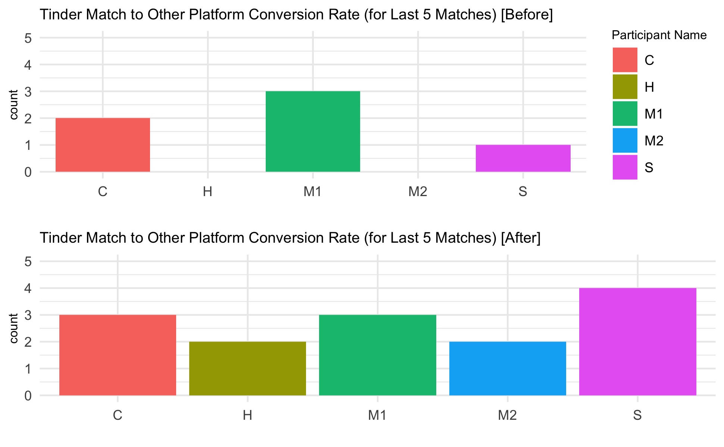

In Figure II, the measurement utilized to track text-etiquette improvement is displayed for the before and after results. Based on Text God’s logic, a successful Tinder conversation typically results in the exchange of information to communicate on other platforms[26]. Therefore, the ability for participants to do so for their last 5 matches at a given moment before and after professional assistance was tracked. Every participant except M1–who was again, the resistant participant–improved. Even participant M2 who received many matches before the experiment improved his text-etiquette according to this measurement.

*Fig III: Dates Comparison Before and After*

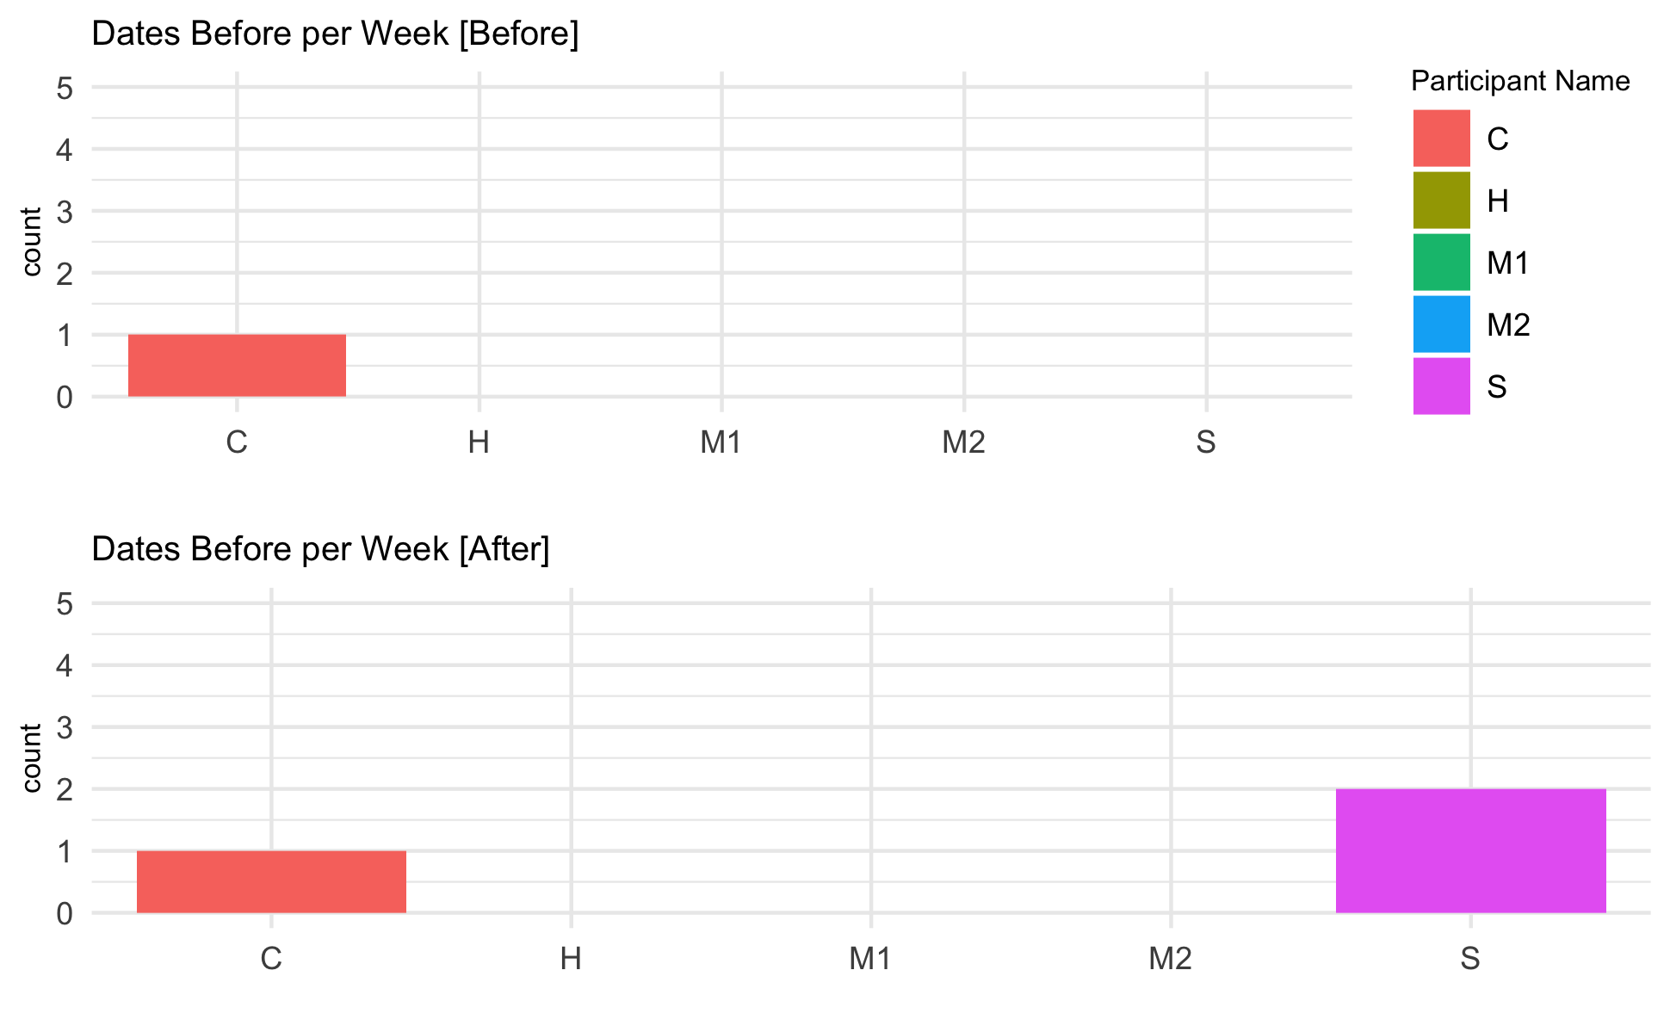

Figure 3 demonstrates the measure for the dates earned per week before and after professional assistance. Ideally, Text God’s methods for profile creation in conjunction with texting-etiquette would have led to more dates. However, this only held true for two participants. While participant C only recorded one date for both the before and after, note that participant C wrote he liked the woman he met after using professional help and did not fancy the first. Participant S produced great results and went on two of his first Tinder dates following the experiment. Overall, participant S tried his very hardest to get the most from the experiment to truly understand if outside assistance could be beneficial. His results indicate that in fact it was. However, it must be noted that participant S tried to embody Text God’s methodology the very most which requires practice and patience to truly master.

*Fig IV: Regression Models for Before and After Professional Assistance*

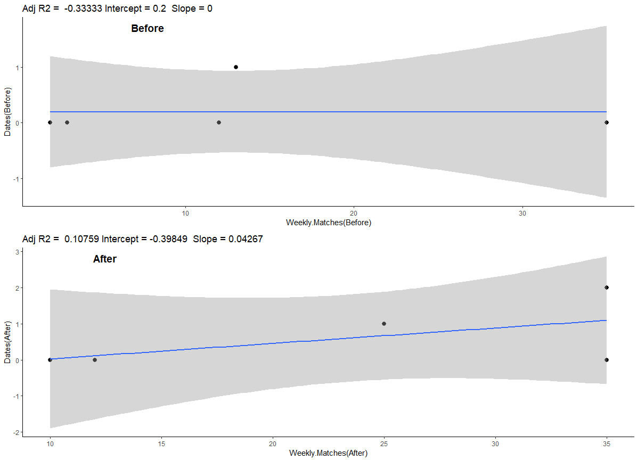

In order to study the impact of weekly matches on Tinder converting to dates, a regression model was developed to understand the influence of matches on dates before and after the experiment. The “before” regression model indicates the slope of the best fit line equals zero. This demonstrates that no correlation exists between the number of weekly matches and dates as a result before professional guidance. The “after” regression model indicates a small but notable correlation between weekly matches and dates following Text God methodology coaching; it is a positive regressive relationship. Both the models reflect the issue of heteroscedasticity, as the data is insufficient for a more meaningful conclusion. The follow-up experiment aims to provide the data needed to establish a more generalizable relationship between these two variables. Additionally, it is imperative to introduce more relevant measurements in the future to understand how the success rate for date conversion could be improved.

**Proposed Solution**

Overall, the first phase of the experiment generated positive results in which each participant benefited to some extent. In order to produce more conclusive findings, a second phase of the experiment with improved measurements to track results is necessary. One underlying issue with the first attempt were the measures used to track profile performance. For the next attempt, the profile ‘likes’ will be tracked instead of using the “30 right swipes measurement.”

Overall, several issues exist with using this measurement. For one, participants complained that on some days, it became tedious to use Tinder enough to generate 30 female profiles they would actually swipe right on. Additionally, participants found it difficult to take into account exactly how many of the 30 right swipes became actual matches. On Tinder, the rate at which users match differs greatly in some cases. One user may match with another a week after swiping right. Therefore, to improve this measurement, every user will be given a premium account so the Tinder profile “likes” can be adequately tracked. This will make for a better measurement and eliminate the confounding variable of having any participants without a premium account.

Tinder Premium alots the premium user a host of advantages including “prioritized likes” which make premium right swipes appear higher in the card stack of users than their free-membership contemporaries[27]. In other words, those with Tinder Premium will be seen sooner and have a possibility to match faster than those without Tinder Premium[28]. Therefore, by giving Tinder Premium to all participants, the playing ground is leveled. During the last experiment, 3/5 participants were premium users which did produce a confounding variable. However, improvement on an individual basis was still more than measurable.

Furthermore, the “dates-liked” measurement will be deleted entirely. Overall, many of the participants during the trial of the experiment saw the measurement as redundant. When the experiment was complete, findings demonstrated they were correct. The hope to generate more dates and to track which of these dates were attractive candidates by each participant before and after the experiment. Results demonstrated dates were far from abundant in addition to the difficulty of achieving dates in such a small time frame.

Therefore, the next experiment will take place using four-week intervals to track results instead of only one. One week did not allot enough time for participants to see as meaningful results as they may have otherwise. Lack of time represented the largest issue for generating results with the first iteration of the experiment. The Text God has a 12-week program where he promises to earn participants a date with 3 girls of interest. During this time, he mentors participants on a one-on-one basis several times a week to monitor progress and results. For at least participant S, 2 women of interest were added to his life in the span of only 1 week. One of which nearly became his girlfriend. While these results were fantastic, the reality is that while the Text God methods do in theory “work” they are not a magic formula to success. Instead, they are a series of guidelines to increase the chances for success. However, they require longer than a week of practice to fully understand and implement.

Ideally, more coaches would be designated to teach participants proper guidelines. Coaches would be required to score at least an 80% on a quiz created to ensure understanding of Text God material. Additionally, potential coaches would demonstrate their ability to turn at least ⅗ of their last matches at a given point into platform conversions. Once dating coaches passed these two criteria for establishing whether they can become dating coaches themselves, they could begin attempting to teach individuals.

However, the reality is that many implicit components exist that make a solid coach outside of familiarity with Text God material. Perhaps most importantly, the coach must have some qualification that demonstrates their viability[29]. Overall, few specialized certification programs university preparation programs exist[30]. In the specialized field of online dating assistance, such qualifications are even more sparse. In this case, the only real way to have a qualification as an online dating expert would be to scientifically demonstrate success. In this case, the coach designated to each of the 5 young men in the first experiment did demonstrate his ability to coach these young men. However, this only holds true for this single individual. Additionally, his success with the young men was not just due to his familiarity with the material.

Adequate coaches are considered integral components to the lives of those they coach and are vastly able to affect performance, behavior in addition to psychological well-being[31]. Conversely, in the same way coaches can be beneficial, they can also generate debilitating environments and negatively affect people in ways that fall outside of a rough knowledge of the Text God material. Ultimately, a great coach must also be a visionary that takes well to criticism and actively learns to improve at what they do[32]. Furthermore, coaches should be positive role models with a passion for their field. Most importantly, coaches must display commitment in addition to character and integrity as a person[33].

Overall, the dating world is a slippery slope and represents a sensitive topic. Any time a topic is sensitive, the element of social-desirability bias is introduced which can negatively impact a host of factors in an experiment[34]. Overall, the field experiment is not a survey experiment and participants cannot be ‘primed’ in the same way they can in surveys. Instead, a host of not necessarily intuitive implicit cues that stem from a high level of emotional intelligence and compassion must be exhibited to generate the best results from participants. Emotional attributes such as honesty, compassion and virtuousness--all of which are integral for this experiment--are not able to easily be measured quantitatively or jotted down on a resume[35]. Therefore, the same coach for the first experiment would ideally be used for the follow up.

**Research Question:** How much better can you perform on dating

apps (Tinder) with a solid profile and better texting etiquette?

**Sample:** 20 college-aged young men.

**Treatment:** Each participant was to receive Text God profile guidelines gathered from all of Text God’s YouTube videos in addition to proper text etiquette guidelines taught in the Text God "Over The Top Text Game" MasterClass. Participant Tinder performance would be tracked

before and after they learned Text God methodology and profile coaching.

**Measurements:**

* Tinder ‘likes’ on a given day for 24 hours
* Dates
* Ability to convert 5 matches to another platform
  + Note that this just means how the frequency out of the last 5 matches a participant received in a given time frame that they were able to convert from Tinder to another platform of communication. This measurement was generated to indicate and track their texting “game” as it generally requires several successful exchanges back and forth before users then begin to converse on a separate platform[36].
* Super-Likes

**Literature Review**

Overall, an enormity of gender disparity exists on not just the Tinder dating app but across virtually all dating apps. From an evolutionary perspective, women must be more particular with who they choose as romantic partners as they carry more of the burden if they accidentally become pregnant.[37] Therefore, intuitively, it makes plausible sense that women perform ‘better’ on dating apps and generate more profile traction. However, what is not exactly common sense is just how wide the gap is between male and female success on such apps. In the study above, two artificial male model and female model profiles were created and tracked over the course of 24 hours to see how each profile would perform[38]. The truly shocking part of the experiment was just how much better the female profile performed in comparison to the male profile.

*Figure V: Gender Disparity in Dating Apps*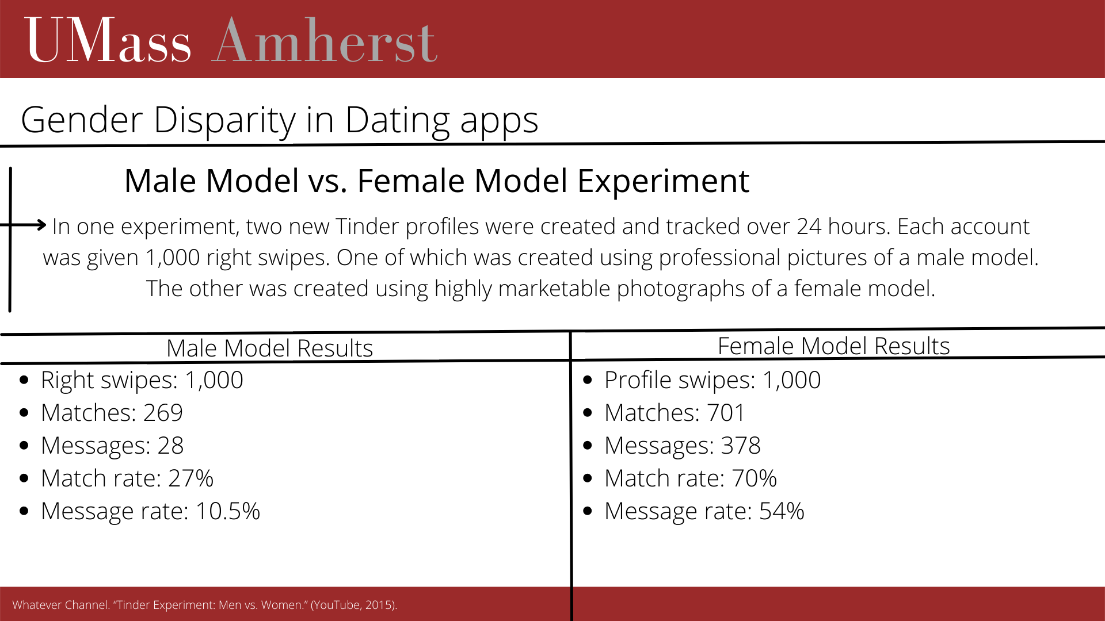

In the experiment pictured above, 1,000 right swipes were designated for each profile. For those that are unfamiliar, a right swipe is equivalent to a ‘yes, I think you’re attractive’ in the world of Tinder. The male model matched with 269 women while the female model matched with 701 men. The male model received a match rate of 27% compared to the female model match rate of 70%. Additionally, the female model received 378 first messages while the male only received 28 first messages. Overall, men are more likely to send first messages than women and studies have proven this[39]. However, it is notable that the female participant received more than 13x the first message rate that the male model did during the experiment.

*Figure VI: Gender Disparity in Dating Apps (continued)*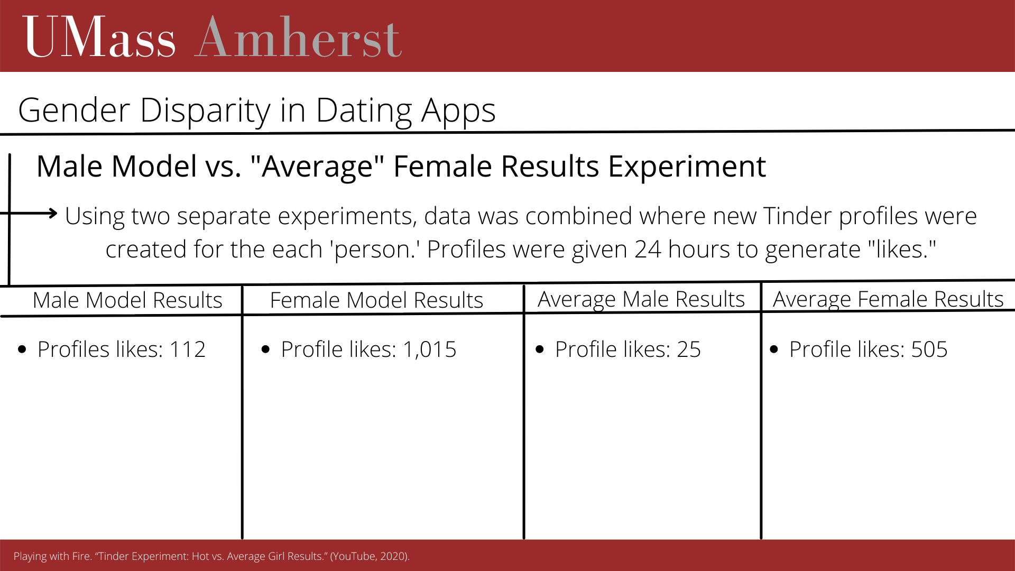

In order to prove this point further, another two experiments were conducted and combined by a different party using only Tinder ‘likes’ this time. For those that are unaware, when someone swipes right on your profile designating a ‘yes’ to you from their profile and you have not had time to see swipe left or right on this individual, the Tinder app generates a ‘like’ that it adds to your ‘likes tab.’ If you are a premium user, you can view all of the likes tabs where you can conveniently swipe left or right one people that have already swiped right and are attracted to you. Overall, profile likes represent a very worthwhile measurement to track profile traction (hence why they will be used instead of the previous measure for the follow-up study).

For the second experiment, a profile was generated for an ‘average’ male and female in addition to a male and female model. The profiles were tracked using profile ‘likes’ over the course of 24 hours to see how much traction each profile received. The results were more shocking than the first experiment. The average female generated over 4 times the amount of traffic generated by the male model in 24 hours[40]. Additionally, the average female earns 20x the amount of profile traffic that the average male does[41]. Additionally, the female model generates 40x the amount of profile traffic generated by the average male. Such disparity is not widely known or explained.

The world of dating apps is more than difficult for the vast majority of heterosexual men. As mentioned prior, one study revealed 85% of the men on dating apps are viewed as below the average level of attractiveness by heterosexual female users[42]. Additionally, studies reveal the top 15% of heterosexual users recieve 78% of messages by female users[43]. Indeed, these statistics fall right in line with the *Paretto rule* which simply states that 20% of people complete 80% of the work generated in any field[44]. Overall, this winner-take-all principle is universally applicable and the same holds true in the world of online dating.

Studies demonstrate “super-star” users exist on the male and female side. However, the case of “super-star” male users, the top 5% of male users receive twice as many messages from female users as the next 5% who generate twice as many messages as the next 5% and so on[45].

Conventionally, women place a higher emphasis on socio-economic status and are more tolerant with regards to looks and age than men tend to be[46]. However, studies demonstrate appearance is increasingly valuable as perceived attractiveness is the most important quality for male and female users[47]. Therefore, the more economically prosperous males of society are less able to lean on their fashionable lifestyle than ever before. One study involved the creation of 32 artificial Tinder profiles with 3 different ranked groups of job prestige[48]. The first group consisted of 3 levels of job prestige for young and professional heterosexual males below the age of 30. The study found women were less motivated to match with men simply because of an affluent lifestyle and a prestigious job title in the world of online dating[49].

Furthermore, talking to women and generating responses and dates is difficult. One study created 4 different ‘pick-up lines,’ designed to elicit different responses from an evenly distributed number of female users from different male profiles[50]. The study was fairly inconclusive because not one of the four lines generated consistent response–or any for that matter–from female users. The study found lines with stereotypes or compliments in addition to a host of other online-dating texting etiquette failures were not received well[51].

Overall, creating a solid profile and avoiding the many pitfalls in the world of online texting-etiquette is difficult. Therefore, the aim is to create an experiment to test the efficacy of the Text God’s methods across a larger sample of 9 to find if they are worthwhile. The world of online dating for men is difficult and a tried and true method of generating results could be very helpful for the majority of men on dating apps.

The sample of the follow-up experiment will consist of 20 college-aged young men to see if the findings of the first experiment are able to convert to a larger and more generalized setting. Overall, college-aged men are particularly viable for the experiment as they are low social value for their sex at this point in their lives[52]. Studies demonstrate women assign more value to socio-economic status than men do[53]. From an evolutionary perspective, women tend to prefer partners that are older in age that have had time to establish themselves financially and help provide for future offspring.[54] Therefore, for this reason, college-aged men are at a particular disadvantage as they have primarily their looks to gain potential matches in the world of online dating. While it is true that women place a declining emphasis on socio-economic status and education and an increasingly large emphasis on looks, women do not hold youth and looks to the same standard men do[55].

For this reason, college-aged men are of particular interest because for the vast majority of students with parents outside of the 1% income bracket, the playing field is much more level than it will become in the future. Therefore, in order to thrive in the world of online dating, college-aged heterosexual men must rely on other sources outside of flaunting a lavish and exciting lifestyle–which studies show may not necessarily help in online dating anyway. However, figures do demonstrate women hold education in high regard, as well as the quality of education. In most cases, the quality of the degree is determined by the National Ranking of the school.

Additionally, it is of great importance that ideally, a distribution of each participant with regards to the Tier of school they attend–and whether or not the school is the Tier 1, 2, or 3 caliber. Research demonstrates a considerable correlation between Tinder success.

and National School Ranking exists. Therefore, a figure was created in order to demonstrate this relationship in a figure.

*Figure VII, National University Ranking vs. Tinder Performance*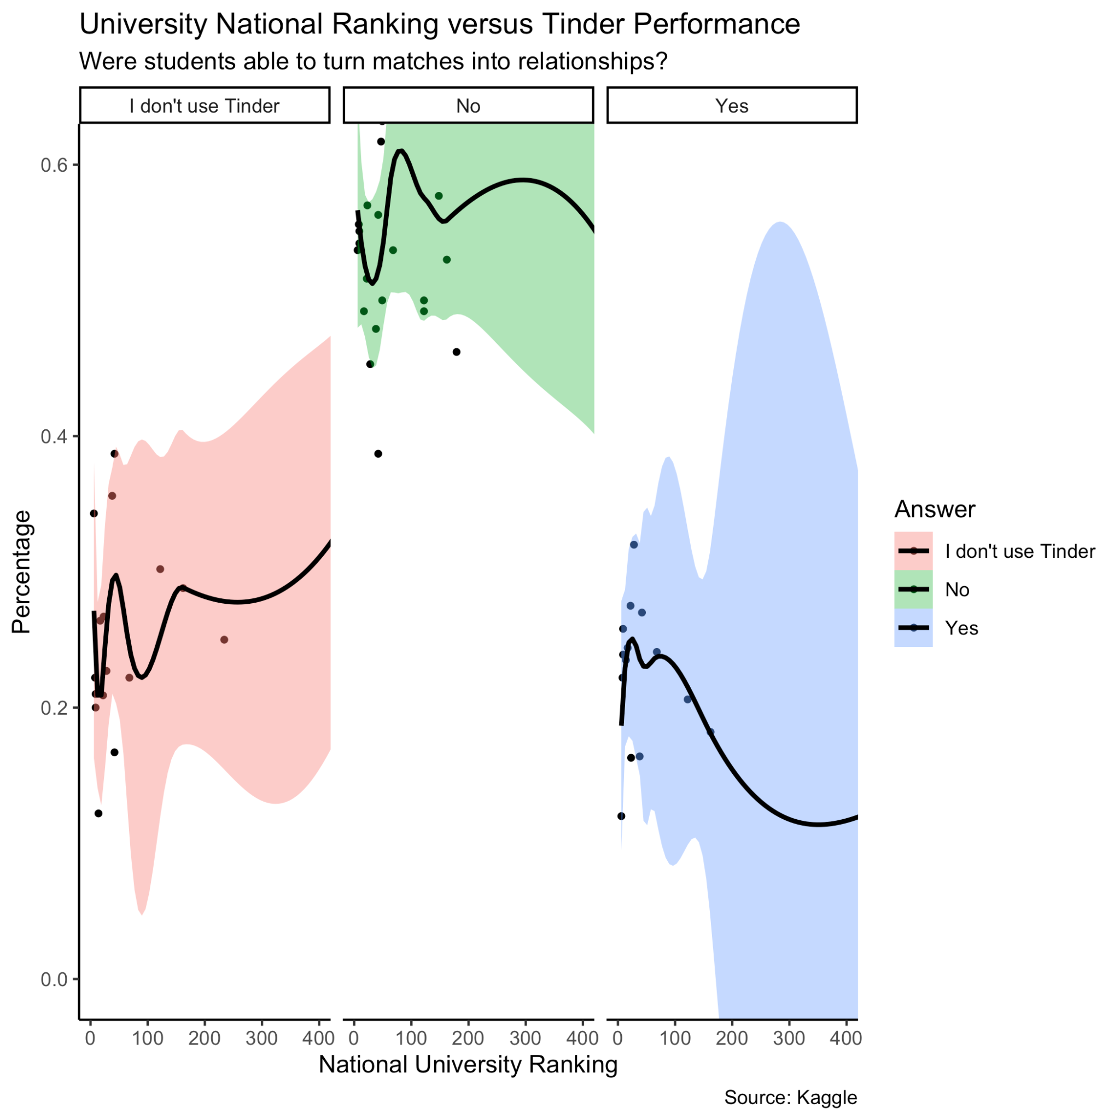

As the figure indicates, students that answered “yes” to successfully turning Tinder matches into relationships occurs more often for students that attend schools in the top 100 universities[56]. Students that attend schools that fall within the top 30 Nationally Ranked Universities garner the best Tinder sutls overall. These individuals answer “yes” to turning matches into relationships more, and “no” to whether they turned a Tinder match into a relationship less than their peers.

The most socially viable asset most college students have is the quality of their education. At this stage in life, college students have not entered the work world where yearly earnings and items that indicate social status influence their results nearly as much. For the vast majority of students with parents outside the 1% income bracket, their education is therefore their most viable asset for attracting partners. In many ways, the quality of education and the grades they achieve at the institutions are at least perceived as telling with regards to future success for males and females.

**Conclusion**

The field experiment undertaken is a multi-phase initiative and is unprecedented work in the domain of online dating. This paper deals with the exploratory phase of study, where the objective has been to develop a method based on “Text God '' dating strategy to give successful profile makeovers developing the fundamental understanding of the challenges and levels of complexities online dating poses. Very few studies have been conducted in which the ways users judge attractiveness was assessed in addition to how this intertwines with messaging strategy[57]. Overall, the interrelationship between peer-interactivity in the world of online dating has been given very little attention as well[58]. This experiment is the first of its kind and the first to assess efficacy of professional help in the world of online dating.

While the Text God’s methodology does not represent a ‘magic formula’ by any means, it does represent a series of helpful guidelines and principles to boost heterosexual male results in the world of online dating. Overall, while the experiment needs a larger and more diverse sample in order to be generalizable, the results are promising. More research is required to gauge whether or not Text God methods are sufficient to keep women interested after dates. Overall, Text God material falls short in this way. Text God’s methods for boosting matches and the chances of a date work to some extent. The most successful participant of the experiment–participant S–claimed he was able to achieve far more matches and dates using this methodology. However, he felt he lacked the proper etiquette to avoid the pitfalls of ruining the actual date and keeping her interested and engaged after. For this particular part of the equation, the participant would likely need to refer to an entirely different framework dedicated specifically to keeping and maintaining women’s interest to avoid ruining the chances of establishing relationships with women of romantic interest.

**Appendix:**

*Figure VIII, Survey Performance of Participants for 1st Study*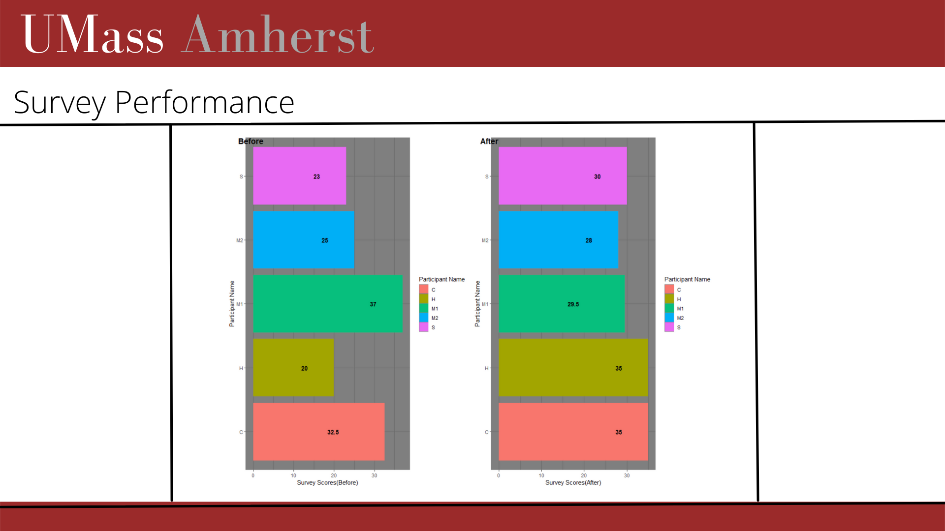

Figure VIII is a visual representation of a metric used in order to track whether participants remembered and understood the methods taught for increasing texting-etiquette by Text God. Every participant scored higher on the second assessment than they had on the first. Additionally, each question was assigned different weights and therefore ‘levels’ of correctness out of 5 points. The most correct answer would receive a 5, then a 2.5 followed by a 1 and a 0. The combination of all question scores for the survey before and after the experiment was added together to form participant scores. Overall, this measure was a bit redundant and will likely be excluded in the future experiment.

**Sources:**

Abolfathi, Niloofar, and Simone Santamaria. *Dating Disruption - How Tinder Gamified an Industry: Tinder’s Gamelike User Experience Enticed Overlooked Users, Led to Rapid Segment Growth, and Ultimately Displaced Industry Incumbents*. MIT Sloan Management Review, 2020. *EBSCOhost*.

Curington, Celeste Vaughan. *The Dating Divide, Race and Desire in the Era of Online Dating.* (University of California Press, 2021).

Dai, Minhao. “Exploring the influences of profile perceptions and different pick-up lines on dating outcomes on tinder: An online experiment.” (School of Communication and Media Studies, 2021).

Dinh, Rachel. “Computational courtship understanding the evolution of online dating through large-scale data analysis.” (Journal of Computational Social Science, 2021).

Epstein, Robert. “The Truth about Online Dating.” (Scientific American Mind, 2021).

Farfields, Louis. *Over the Top Text Game*. (TextGod.com, 2021).

IEEE. “Gender Differences in Online Dating: What Do We Know So Far? A Systematic Literature Review.” (2016 49th Hawaii International Conference on System Sciences (HICSS), 2016. 3859.

International Olympic Committee. “Qualities of a Great Sports Coach.” (ICC, 2021).

Jorgenson Pesch, Alice. “How do you succeed on Tinder? An exploratory study about young women’s self-presentation and strategies online.” (Jonkoping University, 2020) 11.

Kavussanu, Maria. “Coaching Efficacy and Coaching Effectiveness: Examining Their Predictors and Comparing Coaches’ and Athletes’ Reports.”

(The Sport Psychologist, 2008).

Meyer, Robinson. “Dude, She’s (Exactly 25 Percent) Out of Your League. (The Atlantic, 2018).

Murphy, Mark. *Extraordinary Wealth: The Guide to Financial Freedom & An Amazing Life*. (Northeast Private Client, 2019).

Mutz, Diana C. *Population-Based Survey Experiments,.* (Princeton University Press, 2011).

Neyt, Brech. “Job Prestige and Mobile Dating Success: A Field Experiment.” (Ghent University, 2019).

NCSI. “Effective Coaching: Improving Teach Practice and Outcomes for All Learners.” (WestEd National Center for Systemic Improvement, 2015).

Peterson, Jordan. *12 Rules for Life: An Antidote to Chaos.* (Random House Canada, 2018).

Playing with Fire. “Tinder Experiment: Hot vs. Average Girl Results.” (YouTube, 2020).

Playing with Fire. “Tinder Experiment: How Much Does Looks Matter(Average Guy vs. Male Model).” (YouTube, 2021).

Roshan, Ben. “Tinder Millennial Match Rate.” (Kaggle, 2020).

TextGod. “Shooting the Perfect Tinder Profile Picture.” (YouTube, 2019).

TextGod. “Tinder ‘About Me’ Example: Steal My Lines!.” (YouTube, 2019).

The Roommates. “Jordan Peterson shares The Shocking Reason Why Men Today Are Single.” (YouTube, 2021).

Tinder. “Tinder Subscriptions.” (Tinder, 2021).

The Vids. “Jordan Peterson on How Women Rate Men.” (YouTube, 2017).

Varghese, George. “Jordan Peterson explains The 80-20 Rule (Pareto Principle).” (YouTube, 2018).

Wayne, Correy. *How to be a 3% Man, Winning the Heart of the Woman of Your Dreams.* (The Corey Wayne Companies, 2013).

Whatever Channel. “Tinder Experiment: Men vs. Women.” (YouTube, 2015).

Wong, Brittany. “The 6 Online Dating Issues People Complain About Most in Therapy.” (HuffPost, 2020).

Xun, Jiyao. “Measuring the effects of dating websites’ investments in user self-presentation and peer-interactivity on firm performance.” (Journal of Targeting, Measurement and Analysis for Marketing, 2011).

1. Curington, Celeste Vaughan. *The Dating Divide, Race and Desire in the Era of Online Dating.* (University of California Press, 2021) 73.
2. Ibid, 73.
3. Ibid, 74.
4. Epstein, Robert. “The Truth about Online Dating.” (Scientific American Mind, 2021) 30.
5. Epstein, Robert. “The Truth about Online Dating.” (Scientific American Mind, 2021) 32.
6. Abolfathi, Niloofar, and Simone Santamaria. *Dating Disruption - How Tinder Gamified an Industry: Tinder’s Gamelike User Experience Enticed Overlooked Users, Led to Rapid Segment Growth, and Ultimately Displaced Industry Incumbents*. MIT Sloan Management Review, 2020. *EBSCOhost*.
7. Curington, Celeste Vaughan. *The Dating Divide, Race and Desire in the Era of Online Dating.* (University of California Press, 2021) 82.
8. Ibid, 81.
9. Dinh, Rachel. “Computational courtship understanding the evolution of online dating through large-scale data analysis.” (Journal of Computational Social Science, 2021) 7.
10. Peterson, Jordan. *12 Rules for Life: An Antidote to Chaos.* (Random House Canada, 2018) 75.
11. Ibid, 75.
12. Wong, Brittany. “The 6 Online Dating Issues People Complain About Most in Therapy.” (HuffPost, 2020).
13. Wong, Brittany. “The 6 Online Dating Issues People Complain About Most in Therapy.” (HuffPost, 2020).
14. Ibid.
15. Curington, Celeste Vaughan. *The Dating Divide, Race and Desire in the Era of Online Dating.* (University of California Press, 2021) 88.
16. Dinh, Rachel. “Computational courtship understanding the evolution of online dating through large-scale data analysis.” (Journal of Computational Social Science, 2021) 7.
17. Ibid, 7.
18. Ibid, 8.
19. The Vids. “Jordan Peterson on How Women Rate Men.” (YouTube, 2017).
20. Wayne, Correy. *How to be a 3% Man, Winning the Heart of the Woman of Your Dreams.* (The Corey Wayne Companies, 2013) 71.
21. Ibid, 75.
22. Curington, Celeste Vaughan. *The Dating Divide, Race and Desire in the Era of Online Dating.* (University of California Press, 2021) 73.
23. TextGod. “Shooting the Perfect Tinder Profile Picture.” (YouTube, 2019).
24. TextGod. “Tinder ‘About Me’ Example: Steal My Lines!.” (YouTube, 2019).
25. Farfields, Louis. *Over the Top Text Game*. (TextGod.com, 2021).
26. Farfields, Louis. *Over the Top Text Game*. (TextGod.com, 2021).
27. Tinder. “Tinder Subscriptions.” (Tinder, 2021).
28. Tinder. “Tinder Subscriptions.” (Tinder, 2021).
29. International Olympic Committee. “Qualities of a Great Sports Coach.” (ICC, 2021) 1.
30. NCSI. “Effective Coaching: Improving Teach Practice and Outcomes for All Learners.” (WestEd National Center for Systemic Improvement, 2015) 2.
31. Kavussanu, Maria. “Coaching Efficacy and Coaching Effectiveness: Examining Their Predictors and Comparing Coaches’ and Athletes’ Reports.” (The Sport Psychologist, 2008).
32. International Olympic Committee. “Qualities of a Great Sports Coach.” (ICC, 2021) 2.
33. Ibid.
34. Mutz, Diana C. *Population-Based Survey Experiments,.* (Princeton University Press, 2011) 45.
35. Murphy, Mark. *Extraordinary Wealth: The Guide to Financial Freedom & An Amazing Life*. (Northeast Private Client, 2019) 37.
36. Farfields, Louis. *Over the Top Text Game*. (TextGod.com, 2021).
37. IEEE. “Gender Differences in Online Dating: What Do We Know So Far? A Systematic Literature Review.” (2016 49th Hawaii International Conference on System Sciences (HICSS), 2016. 3859.
38. Whatever Channel. “Tinder Experiment: Men vs. Women.” (YouTube, 2015).
39. Dinh, Rachel. “Computational courtship understanding the evolution of online dating through large-scale data analysis.” (Journal of Computational Social Science, 2021).
40. Playing with Fire. “Tinder Experiment: Hot vs. Average Girl Results.” (YouTube, 2020).
41. Playing with Fire. “Tinder Experiment: How Much Does Looks Matter(Average Guy vs. Male Model).” (YouTube, 2021).
42. The Vids. “Jordan Peterson on How Women Rate Men.” (YouTube, 2017).
43. Ibid.
44. Varghese, George. “Jordan Peterson explains The 80-20 Rule (Pareto Principle).” (YouTube, 2018).
45. Dinh, Rachel. “Computational courtship understanding the evolution of online dating through large-scale data analysis.” (Journal of Computational Social Science, 2021) 5.
46. IEEE. “Gender Differences in Online Dating: What Do We Know So Far? A Systematic Literature Review.” (2016 49th Hawaii International Conference on System Sciences (HICSS), 2016.)
47. Jorgenson Pesch, Alice. “How do you succeed on Tinder? An exploratory study about young women’s self-presentation and strategies online.” (Jonkoping University, 2020) 11.
48. Neyt, Brech. “Job Prestige and Mobile Dating Success: A Field Experiment.” (Ghent University, 2019) 3.
49. Ibid, 25.
50. Dai, Minhao. “Exploring the influences of profile perceptions and different pick-up lines on dating outcomes on tinder: An online experiment.” (School of Communication and Media Studies, 2021).
51. Ibid, 6.
52. Meyer, Robinson. “Dude, She’s (Exactly 25 Percent) Out of Your League. (The Atlantic, 2018).
53. IEEE. “Gender Differences in Online Dating: What Do We Know So Far? A Systematic Literature Review.” (2016 49th Hawaii International Conference on System Sciences (HICSS), 2016) 3862.
54. The Roommates. “Jordan Peterson shares The Shocking Reason Why Men Today Are Single.” (YouTube, 2021).
55. Dinh, Rachel. “Computational courtship understanding the evolution of online dating through large-scale data analysis.” (Journal of Computational Social Science, 2021) 1.
56. Roshan, Ben. “Tinder Millennial Match Rate.” (Kaggle, 2020).
57. Dinh, Rachel. “Computational courtship understanding the evolution of online dating through large-scale data analysis.” (Journal of Computational Social Science, 2021) 5.
58. Xun, Jiyao. “Measuring the effects of dating websites’ investments in user self-presentation and peer-interactivity on firm performance.” (Journal of Targeting, Measurement and Analysis for Marketing, 2011) 186.